How to make a Class Mark Book in Excel 2010 – The ‘From Scratch’ Guide

Getting Started
Never used MS Excel before? Don’t worry! In this tutorial we will construct a simple mark book to track your class’ progress. Once you have experienced the power of a spreadsheet program you will never keep a paper version again. So, let’s get started.

- If you are working at School or at College you will need to first log onto the network.
- Once the Windows desktop is in full view select the ‘Start’ Button in the bottom left corner, Then select ‘All Programs’ and from the sub menu select the Microsoft Office folder and click on ‘Microsoft Excel 2010’.

Cells, Sheets, Labels & Values

- The grid that now appears on the screen is known as a workbook. The grid is divided into cells. Each cell has an address or co-ordinates. The first cell for example is A1. This means that the cell is in the first column called A (columns run vertically) and is in row 1 (rows run horizontally). Every cell has an address. There are two ways to find out which cell you are in. The first way is to keep an eye on the Active Cell field. In this window the address of the active cell is written. The second is to look for the cell that has a dark border around it.

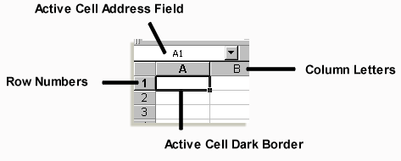

- It is important to also realize you are on page 1 of the workbook. To switch to a fresh sheet select the ‘sheet2’ tab that appears in the bottom left hand corner. Should you ever need a fresh page, for example another class’s marks, then you can navigate between the various pages by selecting the correct sheet.

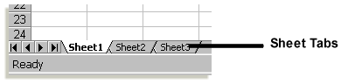

- All labels, usually letters, are by default aligned to the left when entered into any cell. When doing calculations the program excludes all labels. If you want to insert numbers as labels (e.g. grade ‘9 or the year ‘2010) then you insert an apostrophe before typing in the numbers.
- All values (numbers) are by default aligned to the right of a cell.

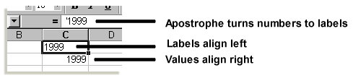

Setting up your Mark Book

- Select a class to be digitized. In cell A1 write the class code e.g. F9Y
- Use Row 2 as a heading row and insert the labels you require to remind you what the figures in each column are. In A2 write, Surname, A3, Initial, A4, Test 1, A5, Test 2 etc. Insert as many headings as you know exist at this stage of the year. You will be able to insert new headings as the year progresses.
- In Row 3 insert the value of each test e.g. total 50 etc.
- Then list all the class members’ surnames in Column A, Initial in Column B and test results if you have any yet in columns C, D etc. Otherwise insert some fictitious figures for this tutorial. Your page should look something like the one below.

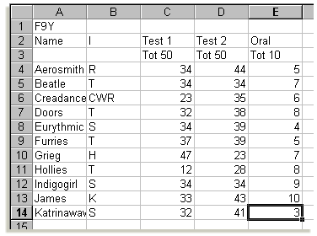

Formatting columns and cell contents

- Often the default size of the column is too small for the label or value that needs to be placed in it, as in the example above. To resize the columns place the mouse directly on the gray division between the column descriptors e.g. between the A and the B column headings. The mouse cursor changes from a white plus sign to a double-sided black arrow. Click the right mouse button and hold it in. Then drag the mouse in the direction you wish to move the column border. A dashed line appears which helps you gauge how far you want to go. Alternatively you can double click and the column will resize to the largest cell item.
- Resize all the columns that are either too big or too small.
- You can also format labels and values the same way you would in MS Word. You can make the contents of the cell bold, italic or underlined by using the B, I and U buttons on the Home ribbon. It is also possible to override the default alignment by using the left, centre and right buttons. To have more formatting control ensure that you have selected the correct cell and right click the mouse. Select ‘Format Cells’ Here you can adjust the Alignment, Font, Border and Fill.

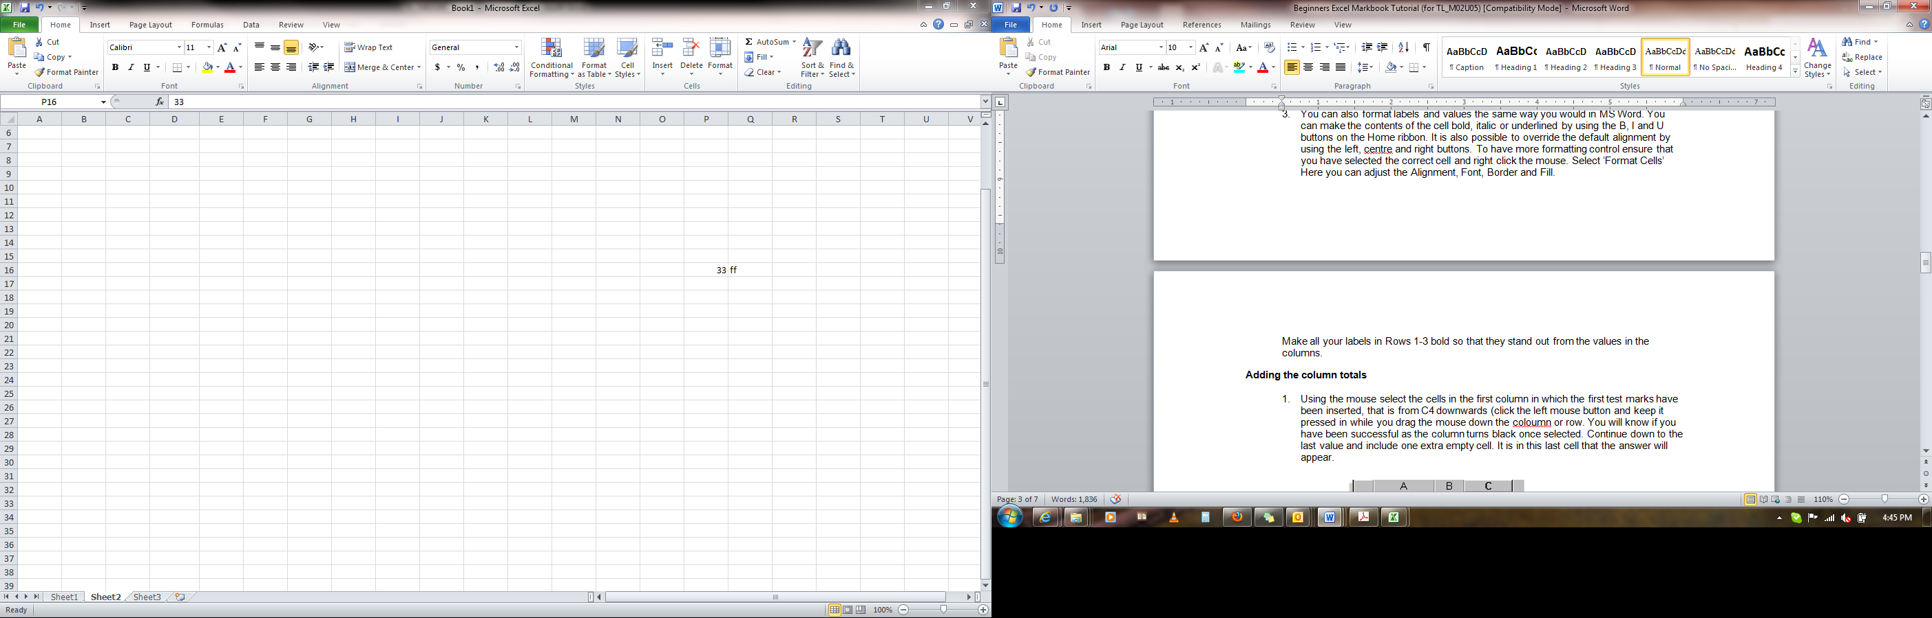

Make all your labels in Rows 1-3 bold so that they stand out from the values in the columns.

Adding the column totals

- Using the mouse select the cells in the first column in which the first test marks have been inserted, that is from C4 downwards (click the left mouse button and keep it pressed in while you drag the mouse down the column or row. You will know if you have been successful as the column turns light blue once selected. Continue down to the last value and include one extra empty cell. It is in this last cell that the answer will appear.

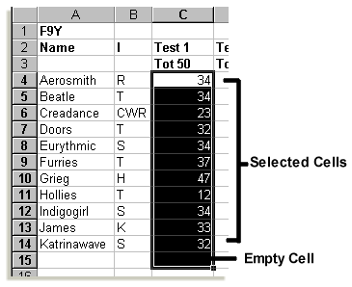

- With the column selected press the ‘Σ’ button at the top of the screen. The total of the column will now appear in the extra cell. Type ‘Total’ in the same row but in column A. Make it both the label and value in that row bold.

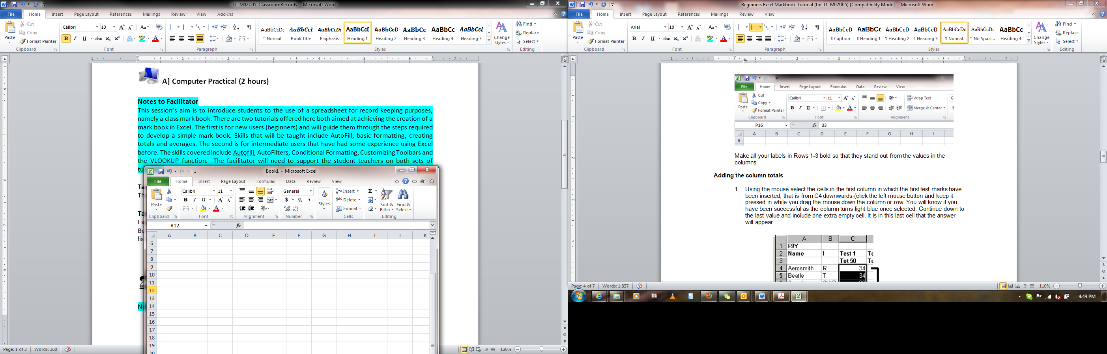

- You can also find out the sum of a series of cells by typing in the following formula where you want the answer to appear, =SUM(c4:c29). The formula means: use the function SUM to add the contents of the column C from Row 4 to Row 29. If your class is bigger or smaller than 25 you will need to adjust the second row number to the last person in your workbook.
- Notice the formula appears in the cell-editing field at the top of the screen. Should you make a mistake and wish to correct the formula. Select the cell in question and then click inside this field. You can then edit the formula as you wish.
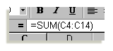

Averaging the column values

- To find out the average for the first test select the cell directly under the column sum. This is where the answer will appear. In this example it would be C16 but you need to check your own workbook.
- In this cell type the following formula: =AVERAGE(C4:C14). What you have asked for is to use the average function to determine the average value in column C from row 4 to row 14. You might again need to change the last row address to suit your particular workbook.
- Type ‘Average’ on the same row but in Column A and make both label and values bold.
- Your mark book should look similar to the one below:

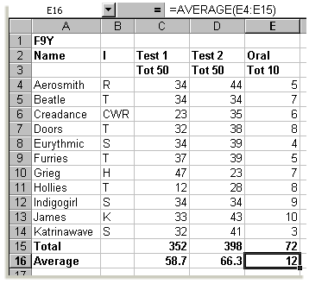

Creating Formulas

- In order to write more intricate formulas you must use the /,*,-,+ signs on the numeric keypad (right hand side of the keyboard) to divide, multiply, subtract or add.
- In your edit field in the panel above your workbook you can design powerful and unique formulas. Place your cursor in the cell where you want the answer to appear. Activate the edit field by clicking the mouse in the edit space. A red  and a green  appear on the left of the edit field when you have successfully activated it.
- Insert an = sign to signal to the program that what appears next is a formula. In the example below column F has been used to work out a term mark. Columns C and D need to be added together and then added to Column E. First, however, this oral mark needs to be converted to a figure out of 50 not 10.
- Place the cursor in F4
- So use the formula: =(E4*5)+C4+D4 This says that first we must multiply the value in E4 by five and then add it to C4 and D4. This provides us with the Raw Term Mark out of 150 for the first pupil.
- We now need to copy this formula to the other class members as we don’t want to write it out again. Select the cell with the valid formula. In the bottom right hand corner of the cell is a small black square. Click and drag the cursor down the column and the formula will be copied to each cell.
- Column G has been used to convert the raw term mark figure to a percentage for the reports. The value in F4 is out of 150 so in cell G4 type the formula =F4/150*100. This formula means divide the value in cell F4 by 150 and multiply it by 100. Copy and paste this formula to all the other pupils in Column G.
- You can now sum and average these two new columns. The average of column G is the class average.
- It is possible to leave out step 7 above if you make your formula more adventurous in step 5. Instead of writing =(E4*5)+C4+D4 you could have written =((E4*5)+C4+D4)/150*100 which is really a combination of both steps. This new answer that now appears in Column F is the report mark out of 100.
- Obviously you can adapt formulas to suit your situation.
- There! You now have a fully functional Mark Book. This book is quite sufficient for our needs but we have hardly scratched the surface of possibilities that Excel offers teachers. However, as you become more familiar with the commands we have practiced here you will discover en route other ways to enhance your mark book.

A few extra tips

- After having entered new marks into the computer print out a copy. The nature of computers and computer files is that they break down and can become corrupted. Therefore keep a copy of your marks on the network and on a disk drive.
- It is good policy to have a ‘hard copy’ and keep it in a file for easy reference. You will need one, anyway, for Parent-Teacher evenings.
- Backup or keep a copy of your mark book file elsewhere so that if your master file becomes corrupted you can access the backed up version.

Andrew Moore – updated 11/08/2011
Copyright: Creative Commons - Attribution

